**LAB 24**

**DHCPv4**

1. Start your Windows 10 VM
2. Using the **ipconfig** command, request the IPv4 address of your VM’s NIC.

Windows recap: Limit the output of this command to only the IPv4 address by piping this command to an appropriate *findstr* command (or *Select-String* in PowerShell).

Paste below a screenshot of the ticked command line and its output.

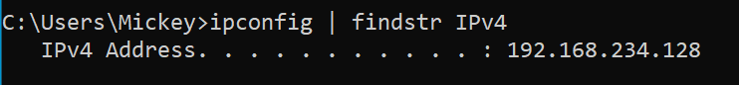

1. With which option of **ipconfig** can you find out, among other things, whether your VM’s NIC has received an IPv4 address via DHCP?

Ipconfig /all 🡪 DHCP enabled - Yes

The output of your command in your VM also shows the IPv4 address of the DHCP server that has leased this address to your VM. This is the DHCPv4 virtual server which runs inside your VMware Workstation/Fusion software. Write down this IPv4 address below.

192.168.234.254

Note that this IPv4 address is the last host IP address from your VMnet8 network 192.168.x.0/24. Remember the figure below from a previous lab. It also showed the DHCP server and DNS server (which is also the default gateway for your VMs) inside your VMware software running ‘behind the scenes’.



If you execute the same command on your laptop host, you would (usually) see the IP address of the DHCP server built into your wireless home router.

1. In the output of the previous command on your VM, have a look at the lines containing Lease info.

Note: you could limit the output of the command to these lines using the same “trick” with *findstr* as previously done.

So what is the lease time?

1 hour and 15 minutes

Note that the lease time of the virtual DHCPv4 server in your VMware software (on a Windows computer) can be found in the file: C:\ProgramData\VMware\vmnetdhcp.conf

1. With option of **ipconfig** can you refresh the DHCP configuration on your PC?

Ipconfig /renew

Check again for how long you can use your IPv4 address. Normally, the “Lease Expire” time should be later than before...

1. Start Wireshark on your host and start a capture session on VMnet8 (to capture all traffic to and from your VM) and run the following 2 commands while capturing.
   1. On your Windows-VM using ipconfig with the correct option, release the IPv4 address of your NIC.

Ipconfig /release

* 1. Renew on your Windows-VM the IPv4 address of your NIC using ipconfig with the correct option.

Ipconfig /renew

* 1. Stop the capturing.

1. Use an appropriate filter in Wireshark to only view the DHCPv4-related packages. Paste below a screenshot of those filtered packages.

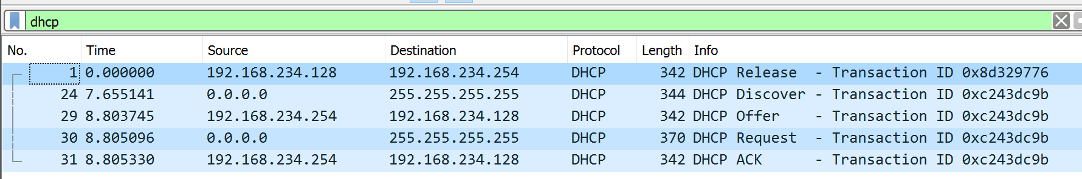

Normally you should (at least) see 5 frames, of which the first is due to the DHCP release using ipconfig. The other 4 frames are the “DORA packets” which result from the renewal using ipconfig.

What IP address does your network card use immediately after releasing its IPv4 address?

0.0.0.0

Which DORA packages use IP broadcasting here?

All packages

1. Multiple clients could simultaneously try to get an IP address via DHCP. What is included in each of the DORA packets to identify each host individually? Take a screenshot of that in one of the DORA packets.



1. Since the NIC of your laptop would like to use its previously assigned IPv4 address, it will also explicitly ask the DHCP server during the Discover phase.

Take a screenshot showing this requested address (together with the corresponding option number).



1. Normally, a DHCP server can distribute much more than just an IP address to a client. Check if the following data were distributed to your DHCP client in this capture and if so, by which option number that happened:

* Lease time 51
* Default Gateway 3
* Subnetmask 1
* DNS server 6

1. Write down below which transport layer protocol DHCPv4 uses.

UDP

Which port is always used by the DHCPv4 server?

67

Which port is always used by the DHCPv4 client?

68